Name: SARWEEN A/L ALAGES

Matrics: 207460

Quality Attribute Assignment

1. Calculate a software availability quality attribute percentage where
   1. The software is down 2 hours per day.

((24-2) *365/24*365) * 100 = 91.67%

* 1. The software is down 24 hours per week.

(((7*24)-24)*52 / (52*7*24)) * 100 = 85.71%

1. Identify the used security techniques for a [Laravel](https://laravel.com/) or [DevExpress XAF](https://www.devexpress.com/products/net/application_framework/) for the following items:
   1. Authentication

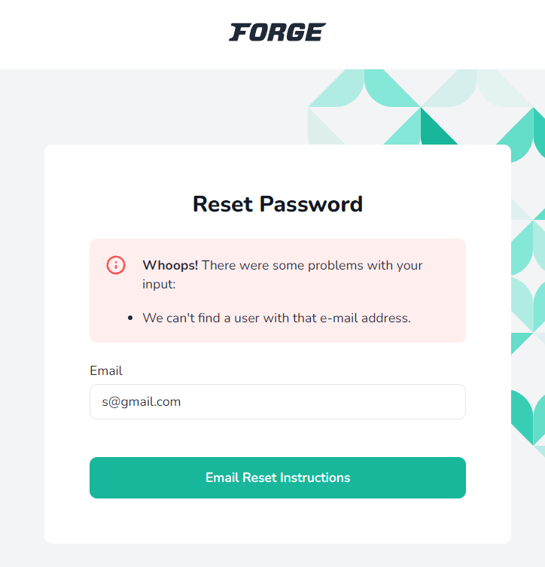

Laravel can identify that the identity of the user does not exist in its database system.

* 1. Authorization.

Laravel does not allow a user with incorrect email and password combination to access an account on their server.

Laravel provides two primary ways of authorizing actions: gates and policies. Gates are simply closures that determine if a user is authorized to perform a given action.

* 1. Encryption.

Laravel uses AES-256 and AES-128 encrypter, which uses Open SSL for encryption. All the values included in Laravel are signed using the protocol Message Authentication Code so that the underlying value cannot be tampered with once it is encrypted.

1. Calculate the estimated performance throughput of a software where:
   1. The average data per order in 1000 byte.

(1000 * 8) bits / 1 order = 8000 bits per order

* 1. The upload bandwidth of the server is 1 mbps.

1 * 1 000 000 bit / 1 second = 1 000 000 bit per second

1/8000 * 1 000 000 = 125 order per second

1. Calculate the estimated performance response time of a software where:
   1. The average data per screen in 500 byte.

500*8 bits / 1 screen = 4000 bits per screen

software with link, formula, framework

* 1. The average number of users in 200.
  2. The download bandwidth of the server is 1 mbps.

1 * 1 000 000 bit / 1 second = 1 000 000 bit per second

4000 / 1 000 000 = 0.004s per screen

0.004s * 200 = 0.8s

4000 * 200 bit / 1 000 000 = 0.8s

1. Regarding question number 4, how many server you need to add to your system in order to reduce response time to 1 sec.

* Justify you answers with required calculation and submit your answers at in your github host.
* We will pick up randomly 5 students next session to present their answers.